Chapter 9, Solution 40.

In the circuit of Fig. 9.47, find i_{o}(t) when:

- ω = 1 rad/s
- ω = 5 rad/s
- ω = 10 rad/s

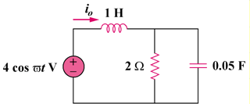

Figure 9.47
For Prob. 9.40.

Solution

- For ,

Hence,
1.872 cos(t – 22.05) A

- For ,

Hence,
890cos(5t – 69.14) mA

- For ,

Hence,
441.7cos(10t – 83.66) mA

